Hafiz M. Fawad FA17-BECE-0018

Code:
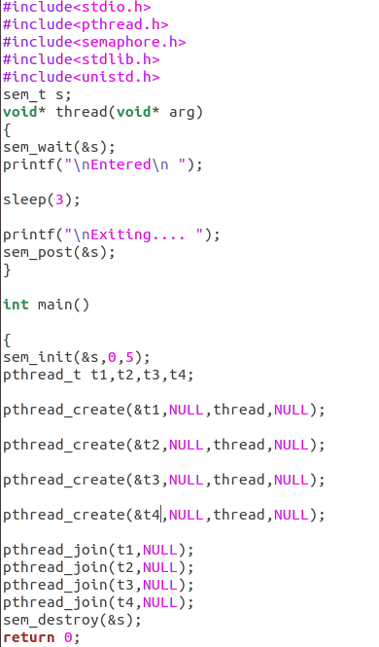

OUTPUT:
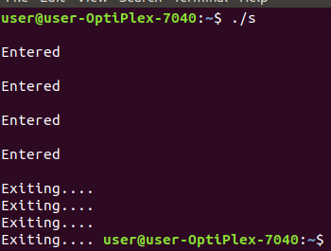
when s=5:

when s=1:

